**Applied Machine Learning**

**Lab Report 4**

**Hafiz Ahmad**

**19l-1316**

**Section-8A**

**INTRODUCTION:**

Experiment aims to investigate logistic regression with a specific dataset. Strategic relapse empowers us to foresee the worth of a reliant variable in light of at least one free factors. We will conduct regression analysis and look at various datasets as part of this task to better comprehend the connections between variables. We can gain new insights and improve our comprehension of the data by examining the regression of one variable in relation to other variables.

**OBJECTIVES:**

The objective of this is to acquire a far reaching comprehension of strategic relapse by investigating different datasets, performing relapse examination, and looking at the connections between factors.

**Procedure:**

We will open Google Colab and import two datasets to begin this experiment. We will figure out how to transfer documents from the work area to Colab, guaranteeing the fundamental libraries like NumPy, pandas, and sklearn are imported ahead of time. We'll move on to logistic regression next. A statistical analysis technique called logistic regression is used to predict a binary outcome using data from previous observations. By examining the relationship between one or more independent variables, it predicts a dependent variable. In this errand, we will begin by changing over object types into twofold ones, as calculated relapse just requires parallel qualities. The accompanying advances frame the strategy:

logistic regression object type conversion into binary values

examining the data with the info command after changing the data type to float.

Analyses of the logistic regression between seasons and temperature. We will import the direct model to play out the relapse.

utilizing the tested model and the predicted model to calculate the confusion matrix.

Importing the metrics library and comparing the tested model to the predicted one is used to calculate accuracy.

The exactness of the calculated relapse is viewed as 75%, demonstrating great execution. We will follow a similar interaction to work out the precision and disarray grid for the excess credits of interest. We will accurately complete the lab in this manner.



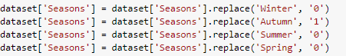



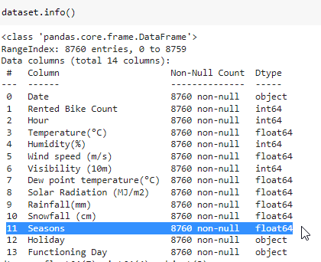

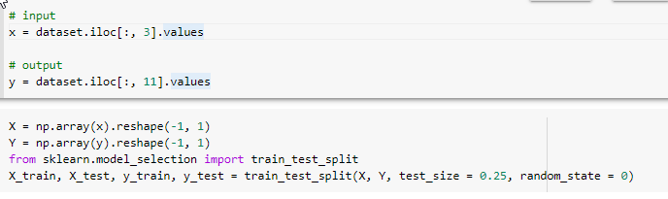  


**Application:**

Logistic regression offers several applications and advantages, especially in forecast and characterization issues. One outstanding use case is misrepresentation discovery, where calculated relapse models assist with recognizing information irregularities that recommend fake exercises.

**Issues:**

No issue was found while performing in the lab.

**Conclusion:**

In conclusion, we now have a complete comprehension of logistic regression thanks to this experiment. To effectively assess the relationships between attributes, we successfully performed logistic regression analysis, which included accuracy and the calculation of a confusion matrix.